CU428 X B2086 (4/4/07) 1L flask
Pair percentage % (1h) | 11.4
Pair percentage % (2h) | 79.8
Pair percentage % (3h) | 92.4
Pair percenta ge % (4h) | 91.2
Pair percenta ge % (6h) | 90.4

CU428 X B2086 -1 (4/9/07) 1L flask
Pair percentage % (1h) | 5.6
Pair percentage % (2h) | 80.9
Pair percentage % (3h) | 92.8
Pair percenta ge % (4h) | 91.0
Pair percenta ge % (6h) | 93.8

CU428 X B2086 -2 (4/9/07) 1L flask
Pair percentage % (1h) | 10.7
Pair percentage % (2h) | 70.5
Pair percentage % (3h) | 90.7
Pair percenta ge % (4h) | 89.4
Pair percenta ge % (6h) | 91.0

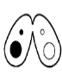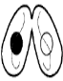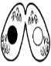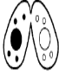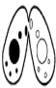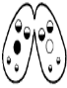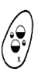

87 90 83

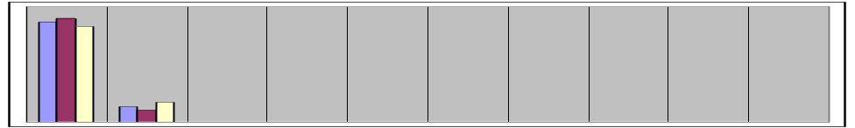
2 hr

13 10 17

100%
Percentage
of cell pairs

0%
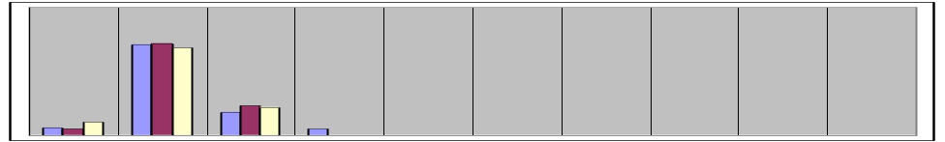
4 hr

6 5 10

71 72 68

18 23 22

5

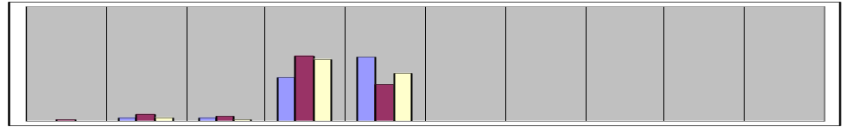
6 hr

5

3 6 3

3 4 1

38 57 54

56
32 42
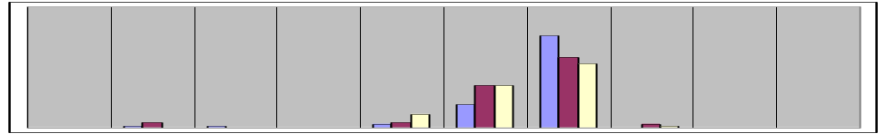
8 hr

1

1 4

3 4 11

35 35
19

76
58 53

3 1

96 84
79
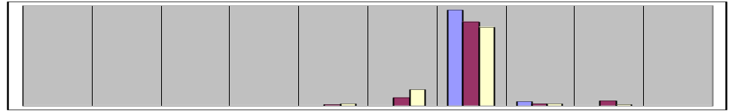
10 hr

1 2

16
8

4 2 2

5 1

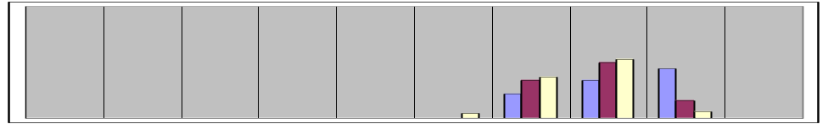
12 hr

4

34 37
22

50 53
34

44
16
6
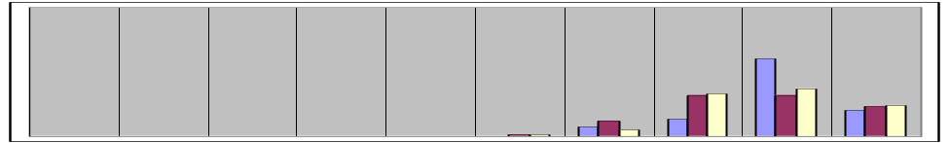
14 hr

1 1

7 12 5

32 33
13

60
32 37

20 23 24

78
74

39
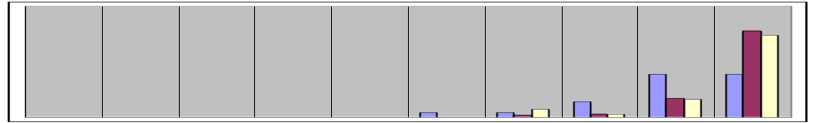
16 hr

4

4 2 7

87 86 79

39
17 16

14
3 3
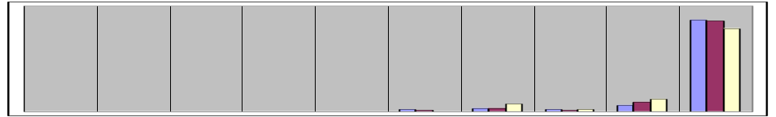
18 hr

2 1

3 3 7

2 1 2

6 9 12

